

REPUBLIC OF CAMEROON REPUBLIQUE DE CAMEROUN

PEACE - WORK - FATHERLAND PAIX - TRAVAUX - PATRIX

**INTERNET PROGRAMMING AND MOBILE PROGRAMMING TASK 6**

**DATABASE DESIGN AND IMPLEMENTATION**

**PROJECT TEAM**

| **LEWIS TEM BUEH** | **FE20A057** |
| --- | --- |
| **MOFAKO BELTUS** | **FE20A065** |
| **MUKOH PRINCEWILL AJECK** | **FE20A068** |
| **EYAAN ZEEYAN ANTHONY JONATHAN** | **FE19A033** |
| **NGULEFAC FOLEFAC FOBELLA** | **FE19A081** |

**THE PURPOSE OF OUR DATABASE.**

The purpose of our database known as Market Database is to a list of products on the market and its related information such as; price of the product, availability status, city in which it is being sold, the quantity in stock etc for the purpose of providing advertisement to the said products, but most especially bringing awareness of the availability, location and price of the product to the customers before they embark on their shopping journey.

**ANALYSIS OF THE DATABASE.**

After careful analysis of our said system, we came out with a class relational diagram and a local schema for our database consisting of five major tables and their respective columns. We made use of PostgreSQL as our DBMS. This choice of tool was due to our experience in working with it and also due to the fact that it is capable of serving the purpose for our database.

**CLASS DIAGRAM FOR DATABASE.**

This diagram shows us the various tables found on our database base, their attributes/columns as well as the relationships and cardinalities between tables.

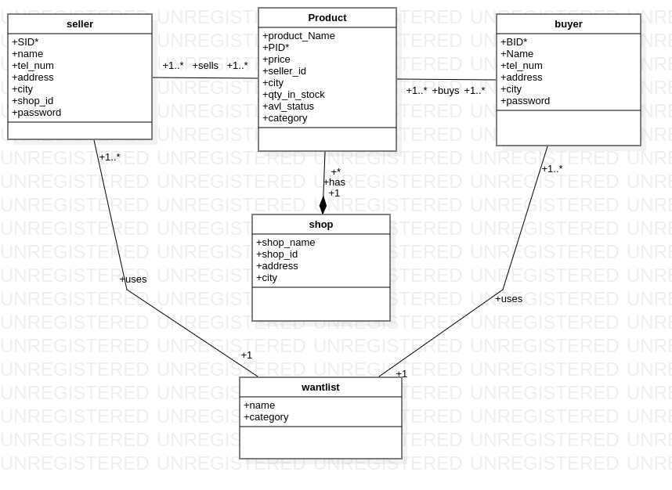

**Figure 1: class diagram for database depicting relationship and cardinalities of tables**

**TABLES:**

* **PRODUCT TABLE:**

This table contains the information of all the products being viewed/posted on the system. It has the following columns;

* **Product id:** this is represented as PID on the system. This is the unique identifier(primary key) of all the products on the system. It is of datatype “big int” and is tagged onto every product uploaded into the system by the seller.
* **product_Name:** the name attributed to every product goes into this field. It is of datatype “name”.
* **price :**  this column contains the price of the variety of products uploaded onto our system. It has the datatype “big int”.
* **Seller_id:** this is a foreign variable obtained from the seller’s table hence acts as our foreign key of this table. It has datatype “int”.
* **Qty_in_stock:** this column contains the amount of products we got stashed up at a shop or storehouse. It has the datatype “int”.
* **City:** this column will carry the city in which each product is being sold in. it has the “text” datatype.
* **Avl_status:** this column will tell the buyers/customers whether the said good is available for grabs in the market or not. It is of datatype “boolean”.
* **Category:** this field will contain information of the type of product that is being posted by the seller, it can be foodstuffs, electronics, cloths etc. it is of datatype “name”.

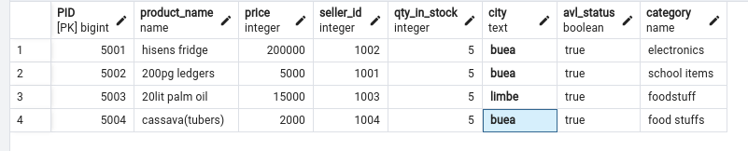

**Figure 2: product table with dummy products.**

* **SELLER TABLE.**

This table contains information of the seller, it has 7 columns.

* **Seller id( SID):** This is the unique identifier(primary key) of all the sellers on the system. It is appended to the seller's information upon signup. It is of datatype “int”.
* **Name:** the name of every seller goes into this column. It is of datatype “name”.
* **Tel_num:** contains the contact number of all sellers. It is of “big int” data type.
* **Address:**  contains the geographical location of sellers. It is of datatype “text”.
* **City:** contains the name of the city where the seller is situated. It is of the “name” datatype.
* **Shop_id:**  this is a foreign key on this table and it refers to the id of the seller’s shop. It has the datatype “int”
* **Password:** contains seller password created at registration. It has the data type “text” and will be encrypted.

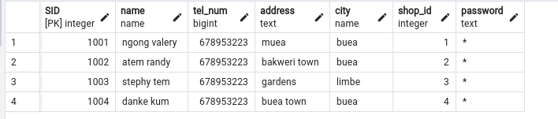

**Figure 3: seller table with dummy records.**

* **BUYER TABLE.**

This table contains information about the buyer. It has six columns in total.

* **Buyer_id (BID):** This is the unique identifier(primary key) of all the buyers on the system. It is appended to the buyer's information upon signup. It is of datatype “int”.
* **Name:** the name of every buyer goes into this column. It is of datatype “name”.
* **Tel_num:** contains the contact number of all buyers. It is of “big int” data type.
* **Address:**  contains the geographical location of buyers. It is of datatype “text”.
* **City:** contains the name of the city where the buyer is situated. It is of the “name” datatype.t”
* **Password:** contains buyer password created at registration. It has the data type “text” and will be encrypted.

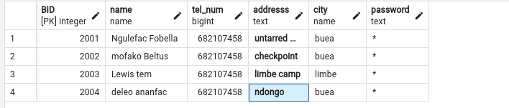

**Figure 4: buyer table with dummy records.**

* **SHOP.**

This table will contain information about the seller's shop. Has five columns.

* **Shop_name:** this column holds the name of the shop and it has the datatype “name”.
* **Shop_id:**  this is the primary of the shop table and uniquely identifies each shop on the system. It is of the “int” data type.
* **Address:** this holds the geographical location of the shop. It is of datatype “text”.
* **City:** holds the city in which the shop is found. It has the “name” datatype.

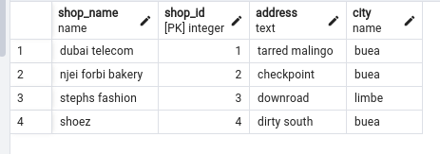

**Figure 5: shop table with dummy shops.**

* **WANTLIST.**

This table will contain the name and category of products that are not being sold in the market.

* **Wname:** this field will hold the name of the products that are not being sold in the market. It has the datatype “text”.
* **Category:** this field will contain information of the type of product that is not being sold in the market. It is of datatype “text”.

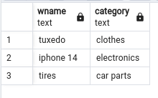

**Figure 6: wantlist table containing dummy records.**

**DATABASE NORMALIZATION.**

In designing our database, we applied a series of normalization techniques; first, second and third normal form, since the majority of databases require just these 3.

* **FIRST NORMAL FORM:**

First normal form states that at every row and column intersection in the table, there exists a single value, and never a list of values. Our database system strictly adheres to this principle of a single value for every intersection of a row and a column hence, it is in first normal form.

* **SECOND NORMAL FORM:**

Second normal form requires that each non-key column be fully dependent on the entire primary key, not on just part of the key. From our tables above , it can be seen that our database is in second normal form since each non-key variable is solely dependent on the primary key.

* **THIRD NORMAL FORM:**

Third normal form requires that not only every non-key column be dependent on the entire primary key, but that non-key columns be independent of each other. In our database, since each non-key element is dependent on the primary key entirely and nothing but the primary key, we can say that our database is in third normal form.